A000-Eur-Czech Republic-Pekárna cave-Harpoons-Bone-13,000 BP

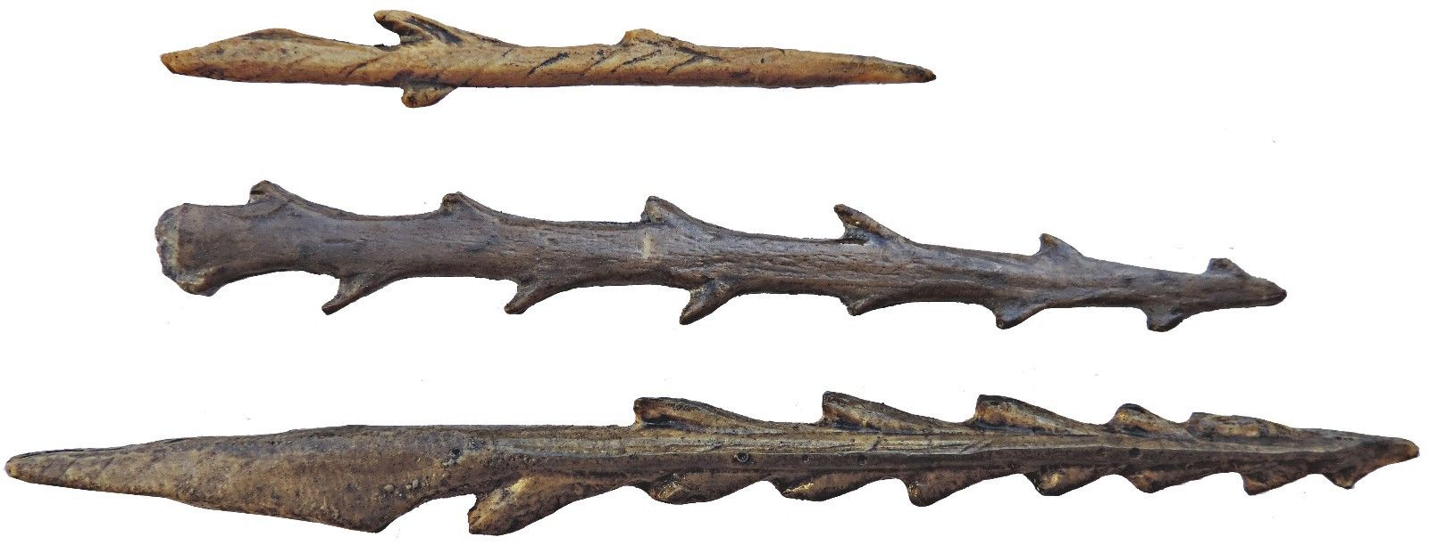

Eur-Czech Republic-Pekárna cave-Harpoons-Bone-13,000 BP

Harpoons from the Pekárna cave in Moravian Karst (The Czech Republic - Europe).Age 12 940 ± 250 - 12 670 ± 80 BP.

**Case No.:**

**Accession No.**

**Formal Label:** Eur-Czech Republic-Pekárna cave-Harpoons-Bone-13,000 BP

**Display Description:**

Harpoons from the Magdalenian culture indicate that the hunter-gatherers from this locality were experimenting with different kinds of weapons for hunting and for warfare. This example indicates that even with the singular shape tere were many experimental designs.

**LC Classification: DB550.A1**

**Date or Time Horizon: 13,000 BP**

**Geographical Area:** Pekárna cave in Moravian Karst, Czech Republic

**Map:**

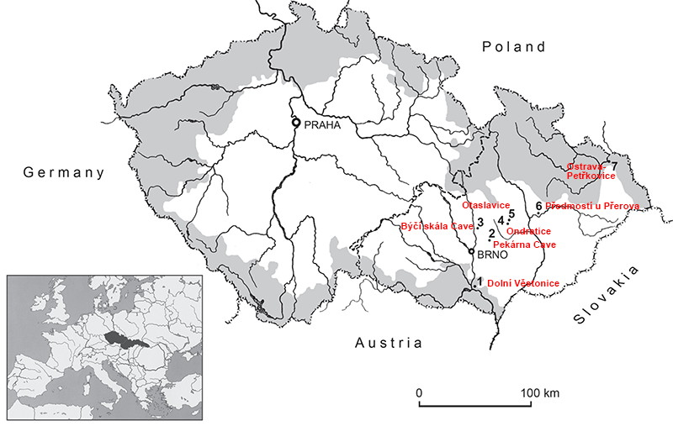

**After http://donsmaps.com/images36/mappekarnaeuropesm.jpg**

**GPS coordinates:**

**Cultural Affiliation:**

**Medium: bone**

**Dimensions:** Length 15.5 cm, 12,5 cm, 8,7 cm.

**Weight:**

**Condition:**

**Provenance:**

**Discussion:**

Engravings of animals (bison, horses, reindeer) and other artefacts have also been found on the archaeological site of the Pekárna cave.

Although the Pekárna cave is located just several kilometres north-east of the outskirts of [Brno](http://lands-of-venuses.eu/v-c-brno/w-c-brno.html) , (the largest Moravian city with 380,000 inhabitants), it lies in the area of the nature reserve of Moravský kras (the Moravian Karst).

The Moravian Karst is a splendid, heavily forested area of caves and cave systems (many of them full of spectacular dripstones), chasms, rocks, subterranean rivers and streams and their streamsinks and resurgences, crisscrossed with marked paths.

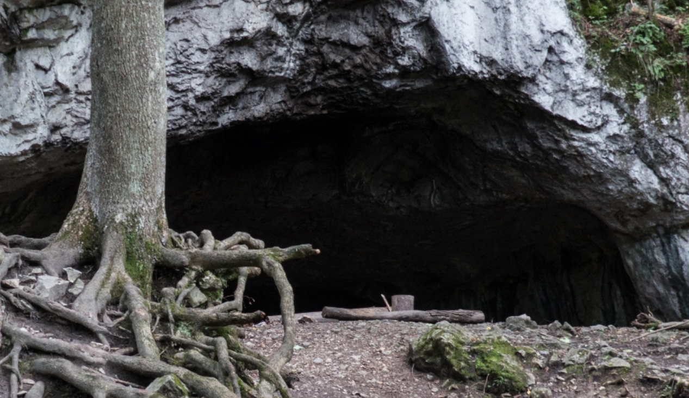

The Pekárna Cave. After http://lands-of-venuses.eu/v-w-images/08-pek/pekarna-002a-cave.jpg